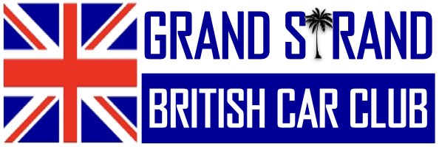

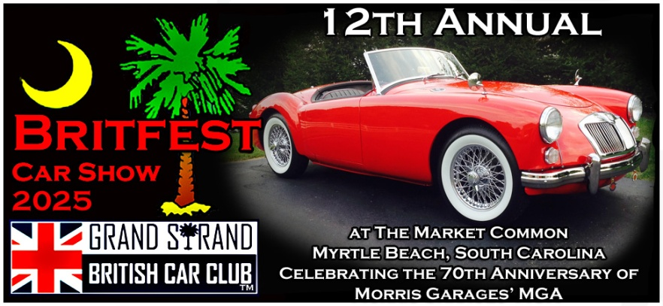

The Grand Strand British Car Club will be hosting the **12th Annual Myrtle Beach BRITFEST British Car Show.** It will be held 9 am to 4pm on Saturday, October 4, 2025, rain or shine. The popular show is held in The Market Common District of Myrtle Beach, and is located at the corner of Iris St. and Johnson Ave.

The show will accommodate up to 140 vehicles that include revered British marques like Austin Healey, Aston Martin, Bentley, Caterham, Jaguar, Land Rover, Lotus, Matchless, MG, Mini, Moke, Morgan, Morris Motors, Norton, Rolls Royce, Scott, Sunbeam, Triumph, TVR, Vincent, and Wolseley. The wide variety of vehicles at the show includes new cars that are made in the UK while others are iconic classics or rare antiques.

The show has 33 different classes of British cars and motorcycles including a non-British category for European vehicles of special interest. The iconic British vehicles at the Myrtle Beach BRITFEST British Car Show come from across the southeastern United States and can be viewed and enjoyed at this annual show by hundreds of people. Spectators are free as are the passengers of the British cars exhibiting at the show.

Starting June 1, 2025 British car and motorcycle owners can register up to 3 vehicles online via the club website as well as access additional information about the show. Please click on <https://grandstrandbritishcarclub.com>

[Register vehicles for Myrtle Beach BRITFEST Car show](https://grandstrandbritishcarclub.com/2025-10-04-britfest-2025-registration/)